# Lab 6. Basic control action in dynamic systems

**Name:**

**ITMO ID:**

## Specialization: Automation

## Objective

To get acquainted with the principles of synthesis of control systems for technical systems in the Simulink software environment.

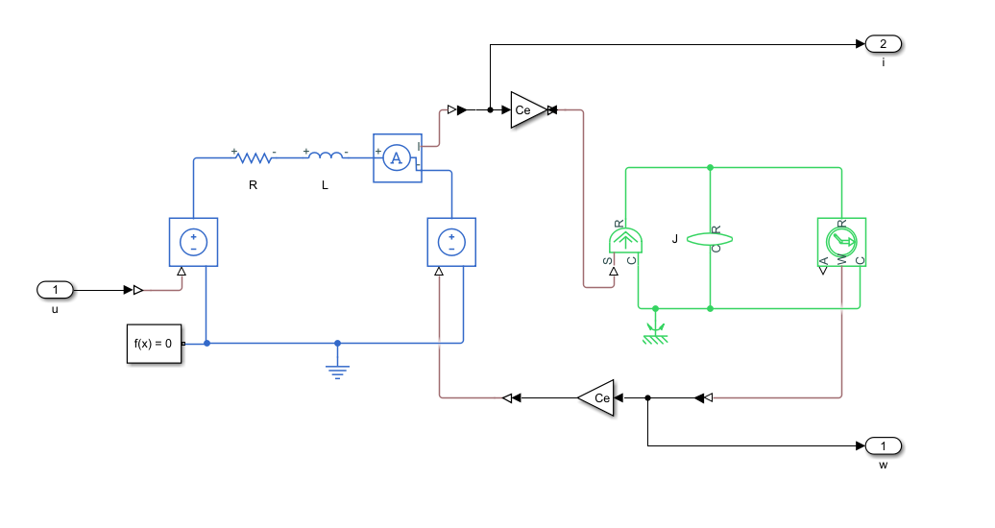

Figure 1. Simulation scheme of the electromechanical system DC motor – mechanical load.

## Initial data

|  |  |  |  |  |  |
| --- | --- | --- | --- | --- | --- |
| **Parameter** | ***R*** | ***L*** | ***Ce*** | ***J*** | ***τ*** |
| **Value** | **2.0993Ohms** | **0.0219mH** | **1.9901 V*s/rad** | **0.9168 kg*m2** | **0.01 s** |

**1. Build a simulation circuit.**

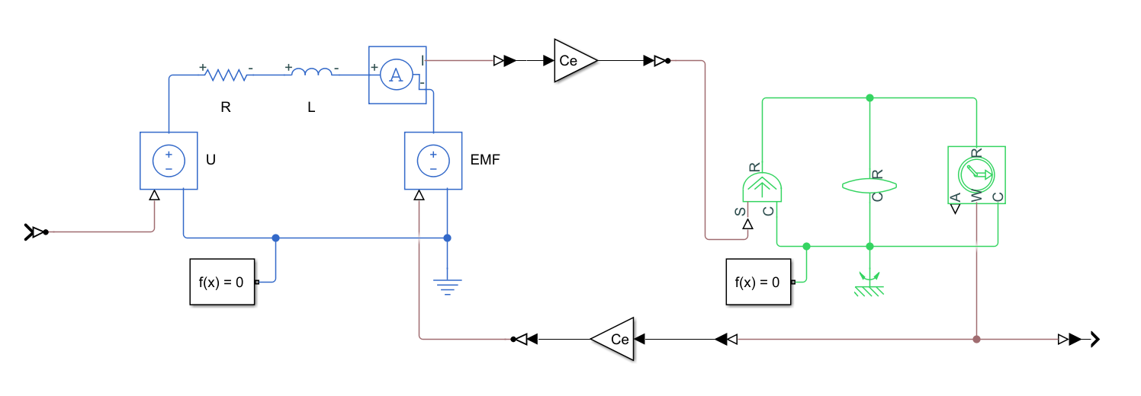

**Figure 2.** Simulation circuit.

**2. Calculate the transfer function of the control object from the control signal to the controlled coordinate (speed).**

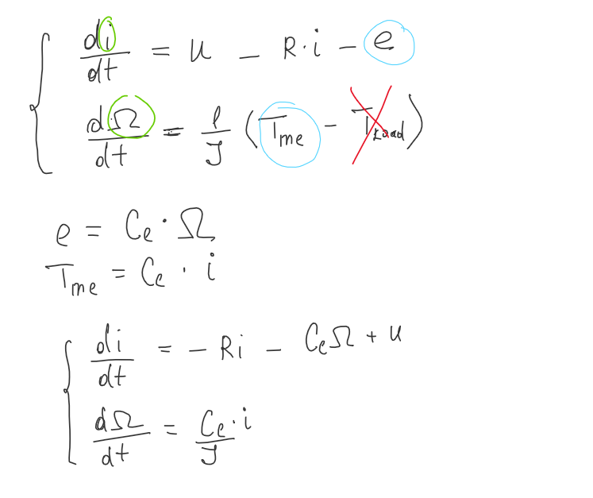

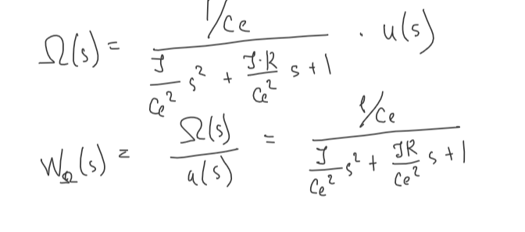

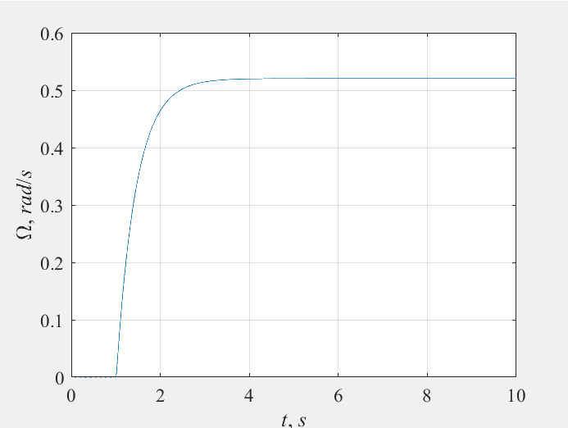.

**Figure 3.** Transient responce.

**3. Calculate coefficients for P-controller, PI-controller and PID-controller by Ziegler Nichols method.**

|  |  |  |  |
| --- | --- | --- | --- |
| Regulator | K­P | K­I | KD |
| P-controller | 49 | - | - |
| PI-controller | 44 | 742 | - |
| PID-controller | 58.8 | 1650 | 0.52 |

**4. Simulate the synthesized control system.**

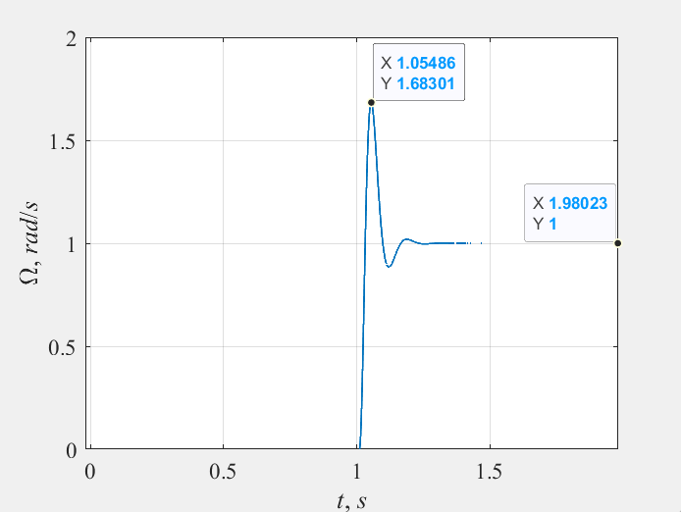

1. P-controller

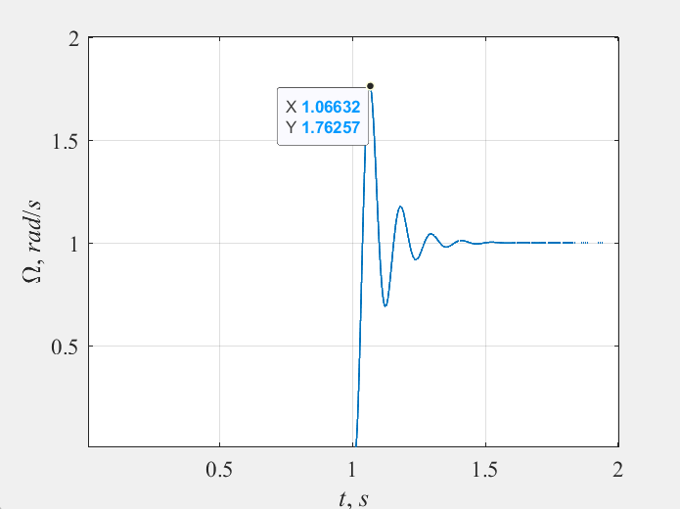

1. PI-controller

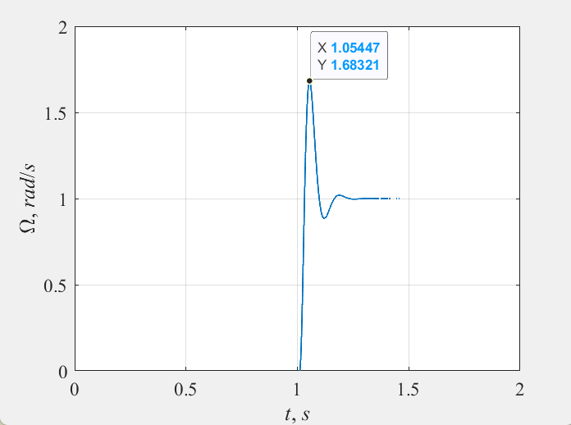

1. PID-controller

**Figure 4.** Graph of velocity for reference signal g(t) = 1 rad/s.

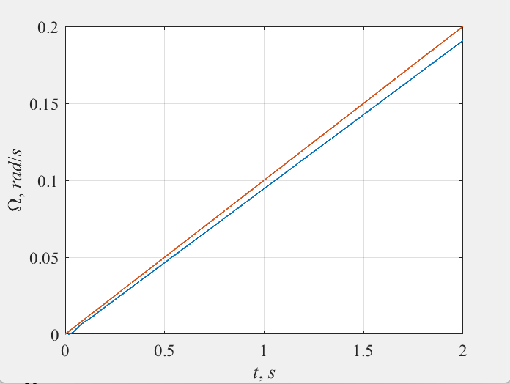

1. P-controller

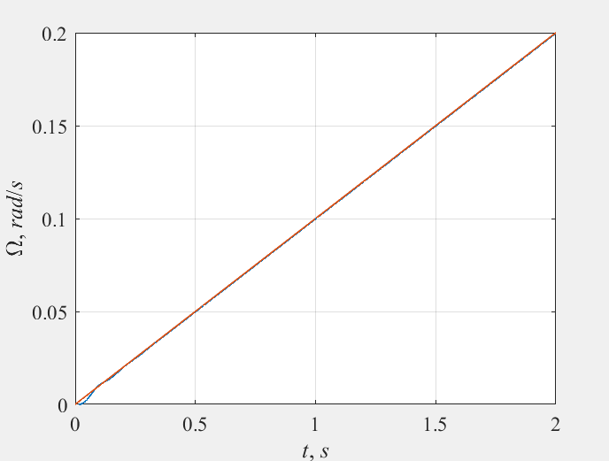

1. PI-controller

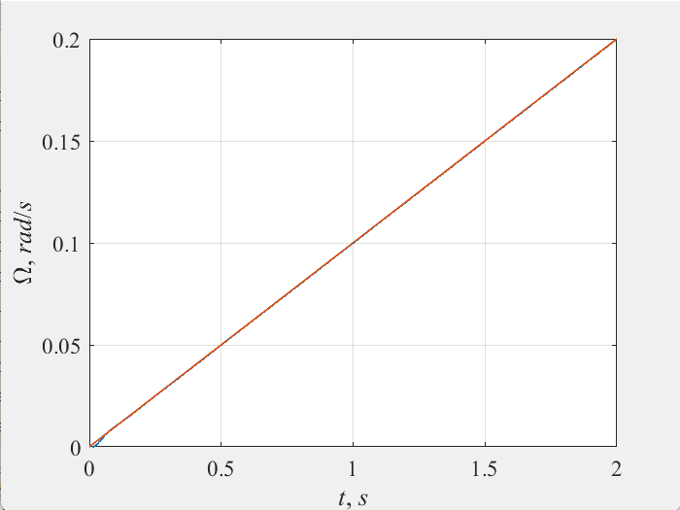

1. PID-controller

**Figure 5.** Graph of velocity for reference signal g(t) = 0.1∙t.

**5. Determine the quality indicators of control systems for each regulator.**

|  |  |  |  |  |
| --- | --- | --- | --- | --- |
| Regulator | Overshoot | Transient time | Steady state error (g(t) = const) | Fluctuation index |
| P-controller | 0.68 |  | const | 1.04 |
| PI-controller |  |  | 0 | 1.05 |
| PID-controller |  |  | 0 | 1.001 |